October
2026
Summit Orthodontics
 |  |  |  |  |  | 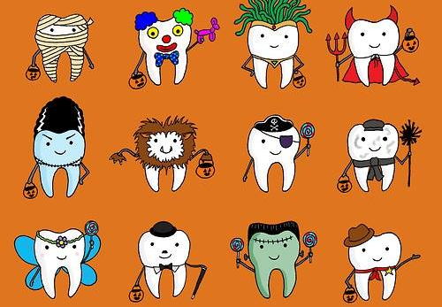

Happy Halloween
We love Halloween in the office. We hope to see you in this month as we always go all out for Halloween. Last year we celebrated Shrek. I wonder what we will be this year. Stay tuned!
Sunday |  | Monday | Tuesday | Wednesday | Thursday |  | Friday | Saturday
 |  |  |  |  | 1 |  | 2 | 3
 |  |  |  |  | Open  8am – 5pm |  | Administrative Day  8am-4pm | Closed
4 |  | 5 | 6 | 7 | 8 |  | 9 | 10
Closed |  | Administrative Day  8am-4pm | Open  8am-5pm | Open  8am-6pm | Open  8am-5pm |  | Administrative  Day  8am-4pm | Closed
11 |  | 12 | 13 | 14 | 15 |  | 16 | 17
Closed |  | Open  8am-5pm | Open  8am-5pm | Open  8am-6pm | Administrative  Day  8am-4pm |  | Administrative Day  8am-4pm | Closed
18 |  | 19 | 20 | 21 | 22 |  | 23 | 24
Closed |  | Administrative Day  8am-4pm | Open  8am-5pm | Open  8am-6pm | Open  8am-5pm |  | Open  8am-5pm | Closed
25 |  | 26 | 27 | 28 | 29 |  | 30 | 31
Closed |  | Open  8am-5pm | Open  8am-5pm | Open  8am-6pm | Open  8am-5pm |  | Administrative Day  8am-4pm | Happy Halloween
On Administrative Days we have a staff member available to answer your calls, schedule an appointment or take a payment.
Dr. Wiggins and Dr. Boswell are not in the office on those days to assist patients.

